Aerobic Respiration
Aerobic cellular respiration is the process of converting the chemical energy of organic molecules into a form immediately usable by organisms. Glucose may be oxidized completely if sufficient oxygen is available, by the following reaction:
C₆H₁₂O₆ + 6O₂(g) → 6 H₂O + 6 CO₂(g) + energy
All organisms, including plants and animals, oxidize glucose for energy. Often, this energy is used to convert ADP and phosphate into ATP. In this experiment, the rate of cellular respiration will be measured by monitoring the consumption of oxygen gas.
Many environmental variables might affect the rate of aerobic cellular respiration. Temperature changes have profound effects upon living things. Enzyme-catalyzed reactions are especially sensitive to small changes in temperature. Because of this, the metabolism of ectotherms, organisms whose internal body temperature is determined by their surroundings, are often determined by the surrounding temperature. In this experiment, you will determine the effect temperature changes have on the aerobic respiration of yeast.

OBJECTIVES
In this experiment, you will
- use a computer to measure changes in dissolved oxygen concentration.
- study the effect of temperature on cellular respiration.
- make a plot of the rate of cellular respiration as a function of temperature.

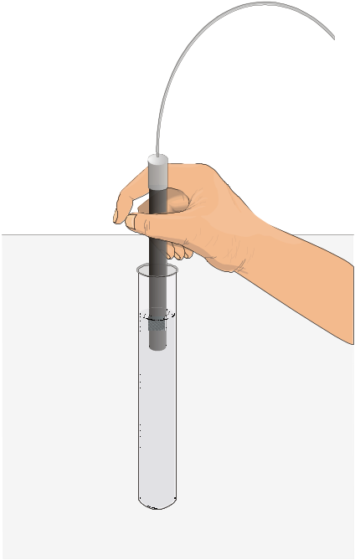
Figure 1
MATERIALS
Power Macintosh or Windows PC | two 600-mL beakers (for water bath)
Vernier computer interface | 2-mL pipette or 10-mL graduated cylinder
Vernier Dissolved Oxygen Probe | pipette bulb or pump
Vernier Temperature Probe | ring stand (optional)
Logger Pro | test tube rack
two 28 X 150 mm test tubes or vials | utility clamp
1% glucose solution | warm and cool water
two 16 X 150 mm test tubes | wash bottle with distilled water
25-mL graduated cylinder | yeast solution

PRE-LAB procedure
Important: Prior to each use, the dissolved oxygen probe must warm up for a period of 10 minutes as described below. If the probe is not warmed up properly, inaccurate readings will result. Perform the following steps to prepare the Dissolved Oxygen Probe.
1. Prepare the Dissolved Oxygen Probe for use.
- Unscrew the membrane cap from the tip of the probe.
- Using a pipet, fill the membrane cap with 1 mL of DO Electrode Filling Solution.
- Carefully thread the membrane cap back onto the electrode.
- Place the probe into a container of water.
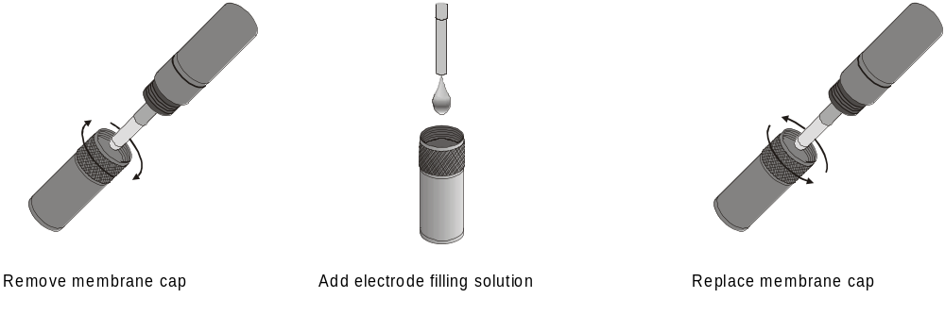
2. Plug the Dissolved Oxygen Probe into Channel 1 of the Vernier interface. Connect the Temperature Probe to Channel 2.
3. Prepare the computer for data collection by opening the Experiment 17 folder from the Biology with Computers folder of Logger Pro. Then open the experiment file that matches the probe you are using. Two plots are displayed. A dissolved oxygen vs. time plot and a temperature vs. time plot. The horizontal axis for both plots has time scaled from 0 to 2 minutes. The first plot has dissolved oxygen scaled from 0 to 16 mg/L. The second plot has temperature scaled from 0 to 30°C. The data rate is set to 20 samples/minute.
4. It is necessary to warm up the Dissolved Oxygen Probe for 10 minutes before taking readings. To warm up the probe, leave it connected to the interface, with Logger Pro running, for 10 minutes. The probe must stay connected at all times to keep it warmed up. If disconnected for a few minutes, it will be necessary to warm up the probe again.
5. You are now ready to calibrate the Dissolved Oxygen Probe.
- If your instructor directs you to use the calibration stored in the experiment file, then proceed to Step 6.
- If your instructor directs you to perform a new calibration for the Dissolved Oxygen Probe, follow this procedure.
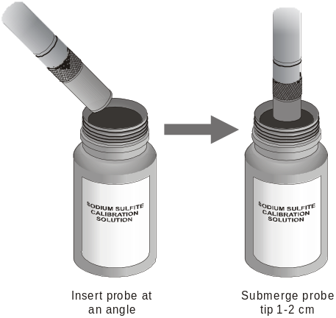
Zero-Oxygen Calibration Point
- Choose Calibrate from the Experiment menu and then click .
- Remove the probe from the water and place the tip of the probe into the Sodium Sulfite Calibration Solution. Important: No air bubbles can be trapped below the tip of the probe or the probe will sense an inaccurate dissolved oxygen level. If the voltage does not rapidly decrease, tap the side of the bottle with the probe to dislodge any bubbles. The readings should be in the 0.2- to 0.5-V range.
- Type “0” (the known value in mg/L) in the edit box.
- When the displayed voltage reading for Input 1 stabilizes, click .
Saturated DO Calibration Point
- Rinse the probe with distilled water and gently blot dry.
- Unscrew the lid of the calibration bottle provided with the probe. Slide the lid and the grommet about 2 cm onto the probe body.
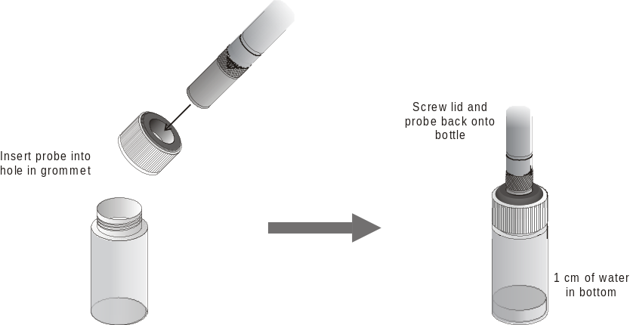
- Add water to the bottle to a depth of about 1 cm and screw the bottle into the cap, as shown. Important: Do not touch the membrane or get it wet during this step. Keep the probe in this position for about a minute.
- Type the correct saturated dissolved-oxygen value (in mg/L) from Table 2 (for example, “8.66”) using the current barometric pressure and air temperature values. If you do not have the current air pressure, use Table 3 to estimate the air pressure at your altitude.
- When the displayed voltage reading for Input 1 stabilizes (readings should be above 2.0 V), click and then click .
- From the File menu, select Save As and save the current experiment file.

PROCEDURE
6. Obtain and wear goggles.
7. Set up two water baths, one at room temperature, approximately 20 – 25°C, and one at approximately 10°C. A water bath is simply a large beaker of water at the correct temperature. Obtain two 600-mL beakers and place about 200 mL of water in each. Add ice to attain 10°C in the cool water bath.
8. Obtain two clean, small test tubes. Label them “1” and “2”. Place 2 mL of the yeast solution into each test tube.
9. Obtain two clean, large test tubes and label them “A”, and “B”. Place 20 mL of the glucose solution into each test tube.
10. Place test tube 1 and test tube A in the warm water bath and place test tube 2 and test tube B in the cool water bath.
11. After test tube 1 and test tube A reach the temperature of the water bath,
- seal test tube A and vigorously mix the contents for about 60 seconds to aerate the solution.
- return test tube A to the water bath and insert the Dissolved Oxygen Probe as shown in Figure 1. Place the Temperature Probe into the water bath.
- gently and continuously stir the solution with the probe for 2 – 3 minutes, or until the dissolved oxygen reading is stable.
- gently mix test tube 1 to suspend the yeast.
- remove the probe from test tube A and add 2 mL of yeast solution from test tube 1.
- place the Dissolved Oxygen Probe into test tube A.

12. Gently and continuously stir the solution with the probe.
13. After 10 seconds, start data collection by clicking .
14. If the dissolved oxygen concentration drops below 1.0 mg/L, stop the experiment by clicking . Otherwise data collection will stop after 2 minutes.
15. When data collection stops remove the Dissolved Oxygen Probe. Click on the plot of temperature vs. time with the mouse pointer. Click the Statistics button, , and record the mean temperature in Table 1. Close the statistics box by clicking in the top right corner of the box.
16. Determine the rate of aerobic respiration.
- Click on the plot of dissolved oxygen vs. time with the mouse pointer.
- Click the Regression button, , to perform a linear regression. A floating box will appear with the formula for a best fit line.
- Record the slope of the line, m, as the rate of O₂ consumption in Table 1.

17. Remove the Dissolved Oxygen Probe from test tube A and rinse with water until clean.
18. Repeat Steps 11 – 17, using test tubes “2” and “B”, which are in the cool water bath. Be sure the temperatures of the water bath and both solutions have equilibrated. Note: One of the team members may want to start Step 19 at this time.
19. Prepare two more water baths, one at 40°C and one at 60°C.
20. Repeat Steps 11 – 17, using test tubes “1”, “A” and the water bath at 40°C.
21. Repeat Steps 11 – 17, using test tubes “2”, “B” and the water bath at 60°C.
22. Clean all of the glassware and probes.
23. If time permits,
- Prepare two more water baths, one at 30°C and one at 50°C.
- Repeat Steps 11 – 17, using test tubes “1”, “A” and the water bath at 30°C.
- Repeat Steps 11 – 17, using test tubes “2”, “B” and the water bath at 50°C.

24. Clean all of the glassware and probes. Place the Dissolved Oxygen Probe in a beaker of distilled water.
25. Open the Manual Entry experiment file from the Biology with Computers folder of Logger Pro. Create a graph of rate of respiration vs. temperature. The rate values from Table 1 should be plotted on the y-axis, and the temperature on the x-axis.

DATA
Table 1
Assigned Temperature (°C) | Temperature (°C) | Rate of O2 consumption (mg O2/L/min)
10
20
30
40
50
60

Questions
1. Do you have evidence that aerobic cellular respiration occurs in yeast? Explain.
2. How did temperature affect the rate of respiration in yeast? Explain.
3. Is there an optimal temperature for yeast respiration?
4. It is sometimes said that the metabolism of ectotherms doubles with every 10°C increase in temperature. Do your data support this statement? Explain.
5. What will happen to the yeast after the oxygen concentration in the solution drops to zero? Why will they continue to respire sugar? Explain.

extensionS
1. Design an experiment to measure and compare the effect of other environmental conditions on the respiration rate of yeast.
2. Design an experiment to measure and compare the respiration rate of a different aquatic organism at different temperatures. What changes to this experimental procedure might be necessary?
3. Carry out the experiment you designed in Step 1 or Step 2.
4. Compare the initial concentration of dissolved oxygen you measured at every temperature. What trends do you see? How does this compare to what you expected? Explain.

CALIBRATION TABLES
Table 2: 100% Dissolved Oxygen Capacity (mg/L)
 | 770 mm | 760 mm | 750 mm | 740 mm | 730 mm | 720 mm | 710 mm | 700 mm | 690 mm | 680 mm | 670 mm | 660 mm
0°C | 14.76 | 14.57 | 14.38 | 14.19 | 13.99 | 13.80 | 13.61 | 13.42 | 13.23 | 13.04 | 12.84 | 12.65
1°C | 14.38 | 14.19 | 14.00 | 13.82 | 13.63 | 13.44 | 13.26 | 13.07 | 12.88 | 12.70 | 12.51 | 12.32
2°C | 14.01 | 13.82 | 13.64 | 13.46 | 13.28 | 13.10 | 12.92 | 12.73 | 12.55 | 12.37 | 12.19 | 12.01
3°C | 13.65 | 13.47 | 13.29 | 13.12 | 12.94 | 12.76 | 12.59 | 12.41 | 12.23 | 12.05 | 11.88 | 11.70
4°C | 13.31 | 13.13 | 12.96 | 12.79 | 12.61 | 12.44 | 12.27 | 12.10 | 11.92 | 11.75 | 11.58 | 11.40
5°C | 12.97 | 12.81 | 12.64 | 12.47 | 12.30 | 12.13 | 11.96 | 11.80 | 11.63 | 11.46 | 11.29 | 11.12
6°C | 12.66 | 12.49 | 12.33 | 12.16 | 12.00 | 11.83 | 11.67 | 11.51 | 11.34 | 11.18 | 11.01 | 10.85
7°C | 12.35 | 12.19 | 12.03 | 11.87 | 11.71 | 11.55 | 11.39 | 11.23 | 11.07 | 10.91 | 10.75 | 10.59
8°C | 12.05 | 11.90 | 11.74 | 11.58 | 11.43 | 11.27 | 11.11 | 10.96 | 10.80 | 10.65 | 10.49 | 10.33
9°C | 11.77 | 11.62 | 11.46 | 11.31 | 11.16 | 11.01 | 10.85 | 10.70 | 10.55 | 10.39 | 10.24 | 10.09
10°C | 11.50 | 11.35 | 11.20 | 11.05 | 10.90 | 10.75 | 10.60 | 10.45 | 10.30 | 10.15 | 10.00 | 9.86
11°C | 11.24 | 11.09 | 10.94 | 10.80 | 10.65 | 10.51 | 10.36 | 10.21 | 10.07 | 9.92 | 9.78 | 9.63
12°C | 10.98 | 10.84 | 10.70 | 10.56 | 10.41 | 10.27 | 10.13 | 9.99 | 9.84 | 9.70 | 9.56 | 9.41
13°C | 10.74 | 10.60 | 10.46 | 10.32 | 10.18 | 10.04 | 9.90 | 9.77 | 9.63 | 9.49 | 9.35 | 9.21
14°C | 10.51 | 10.37 | 10.24 | 10.10 | 9.96 | 9.83 | 9.69 | 9.55 | 9.42 | 9.28 | 9.14 | 9.01
15°C | 10.29 | 10.15 | 10.02 | 9.88 | 9.75 | 9.62 | 9.48 | 9.35 | 9.22 | 9.08 | 8.95 | 8.82
16°C | 10.07 | 9.94 | 9.81 | 9.68 | 9.55 | 9.42 | 9.29 | 9.15 | 9.02 | 8.89 | 8.76 | 8.63
17°C | 9.86 | 9.74 | 9.61 | 9.48 | 9.35 | 9.22 | 9.10 | 8.97 | 8.84 | 8.71 | 8.58 | 8.45
18°C | 9.67 | 9.54 | 9.41 | 9.29 | 9.16 | 9.04 | 8.91 | 8.79 | 8.66 | 8.54 | 8.41 | 8.28
19°C | 9.47 | 9.35 | 9.23 | 9.11 | 8.98 | 8.86 | 8.74 | 8.61 | 8.49 | 8.37 | 8.24 | 8.12
20°C | 9.29 | 9.17 | 9.05 | 8.93 | 8.81 | 8.69 | 8.57 | 8.45 | 8.33 | 8.20 | 8.08 | 7.96
21°C | 9.11 | 9.00 | 8.88 | 8.76 | 8.64 | 8.52 | 8.40 | 8.28 | 8.17 | 8.05 | 7.93 | 7.81
22°C | 8.94 | 8.83 | 8.71 | 8.59 | 8.48 | 8.36 | 8.25 | 8.13 | 8.01 | 7.90 | 7.78 | 7.67
23°C | 8.78 | 8.66 | 8.55 | 8.44 | 8.32 | 8.21 | 8.09 | 7.98 | 7.87 | 7.75 | 7.64 | 7.52
24°C | 8.62 | 8.51 | 8.40 | 8.28 | 8.17 | 8.06 | 7.95 | 7.84 | 7.72 | 7.61 | 7.50 | 7.39
25°C | 8.47 | 8.36 | 8.25 | 8.14 | 8.03 | 7.92 | 7.81 | 7.70 | 7.59 | 7.48 | 7.37 | 7.26
26°C | 8.32 | 8.21 | 8.10 | 7.99 | 7.89 | 7.78 | 7.67 | 7.56 | 7.45 | 7.35 | 7.24 | 7.13
27°C | 8.17 | 8.07 | 7.96 | 7.86 | 7.75 | 7.64 | 7.54 | 7.43 | 7.33 | 7.22 | 7.11 | 7.01
28°C | 8.04 | 7.93 | 7.83 | 7.72 | 7.62 | 7.51 | 7.41 | 7.30 | 7.20 | 7.10 | 6.99 | 6.89
29°C | 7.90 | 7.80 | 7.69 | 7.59 | 7.49 | 7.39 | 7.28 | 7.18 | 7.08 | 6.98 | 6.87 | 6.77
30°C | 7.77 | 7.67 | 7.57 | 7.47 | 7.36 | 7.26 | 7.16 | 7.06 | 6.96 | 6.86 | 6.76 | 6.66

Table 3: Approximate Barometric Pressure at Different Elevations
Elevation  (m) | Pressure  (mm Hg) | Elevation  (m) | Pressure  (mm Hg) | Elevation  (m) | Pressure  (mm Hg)
0 | 760 | 800 | 693 | 1600 | 628
100 | 748 | 900 | 685 | 1700 | 620
200 | 741 | 1000 | 676 | 1800 | 612
300 | 733 | 1100 | 669 | 1900 | 604
400 | 725 | 1200 | 661 | 2000 | 596
500 | 717 | 1300 | 652 | 2100 | 588
600 | 709 | 1400 | 643 | 2200 | 580
700 | 701 | 1500 | 636 | 2300 | 571

